1.Concept Map 1: Decision Support Systems (DSS)
Task Description:
Construct a concept map that explains how a Decision Support System (DSS) supports organizational decision-
making.
Core components: Data, Model, User Interface
1. Types of DSS
2. Flow: Data → Analysis → Decision
3. Role in business decision-making
4. Real-world example linkage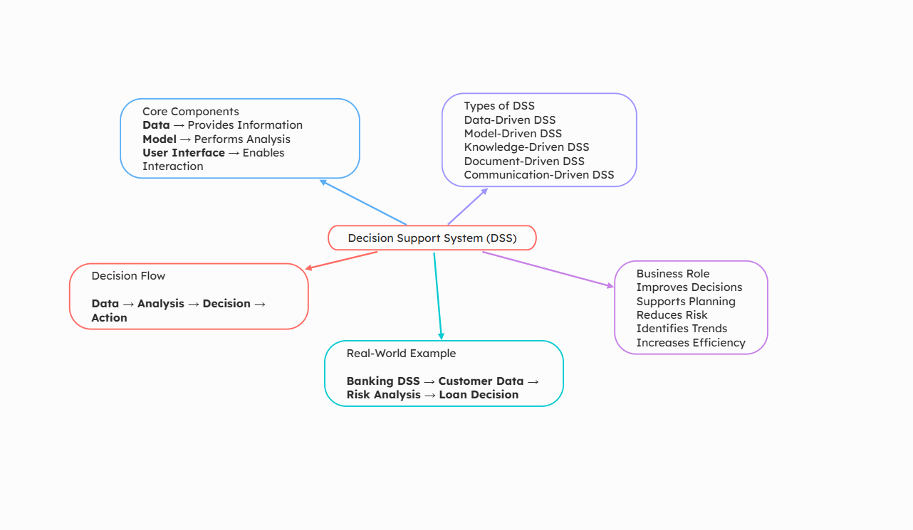

2. Concept Map 2: Operational Systems vs DSS
Task Description:
Develop a comparative concept map that clearly distinguishes Operational Systems (OLTP) and Decision Support
Systems (OLAP).
1. Definitions of OLTP and DSS
2. Differences (data type, purpose, users, processing)
3. Similarities and interactions
4. Real-time vs historical data
5. Example systems (banking vs analytics)
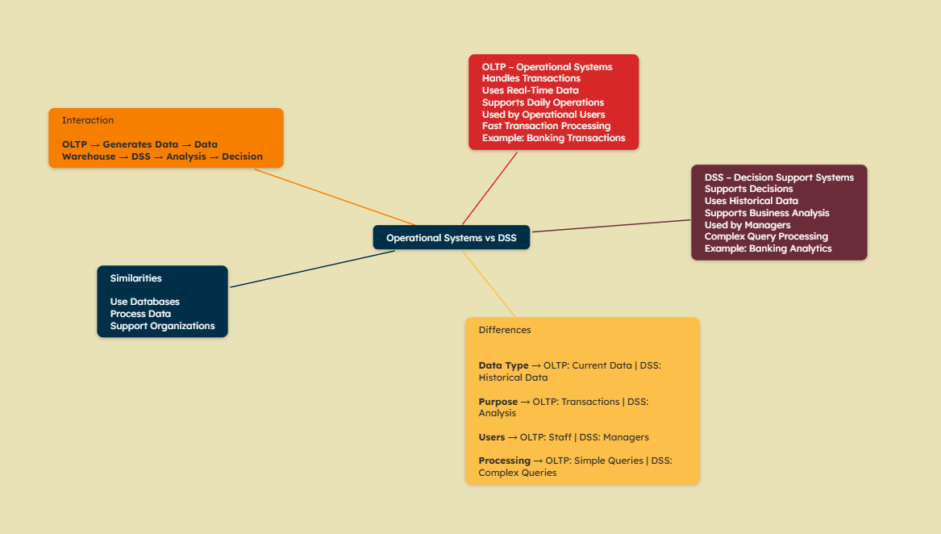

3. Concept Map 3: Architecture of Data Warehouse
Task Description:
Create a hierarchical concept map illustrating the architecture of a Data Warehouse.
1. Data Sources → ETL → Data Warehouse → Data Marts
2. Metadata layer
3. Front-end tools (reporting, OLAP)
4. Data flow direction
5. Role of each layer

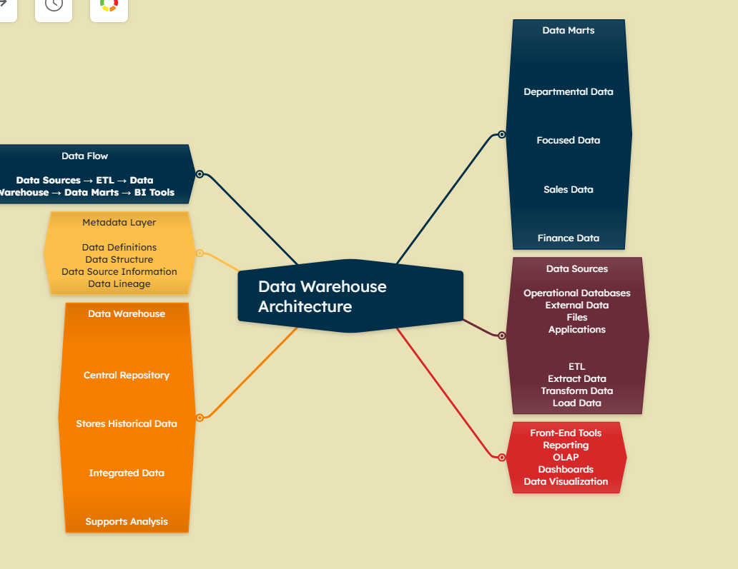

4. Concept Map 4: OLAP, Data Cubes &amp; Dimensional Modelling
Task Description:
Design a concept map that connects OLAP operations, Data Cubes, and Dimensional Modelling techniques.
1. Data cube structure (dimensions, measures)
2. OLAP operations (slice, dice, roll-up, drill-down)
3. Star schema and snowflake schema
4. Fact and dimension tables
5. Analytical usage

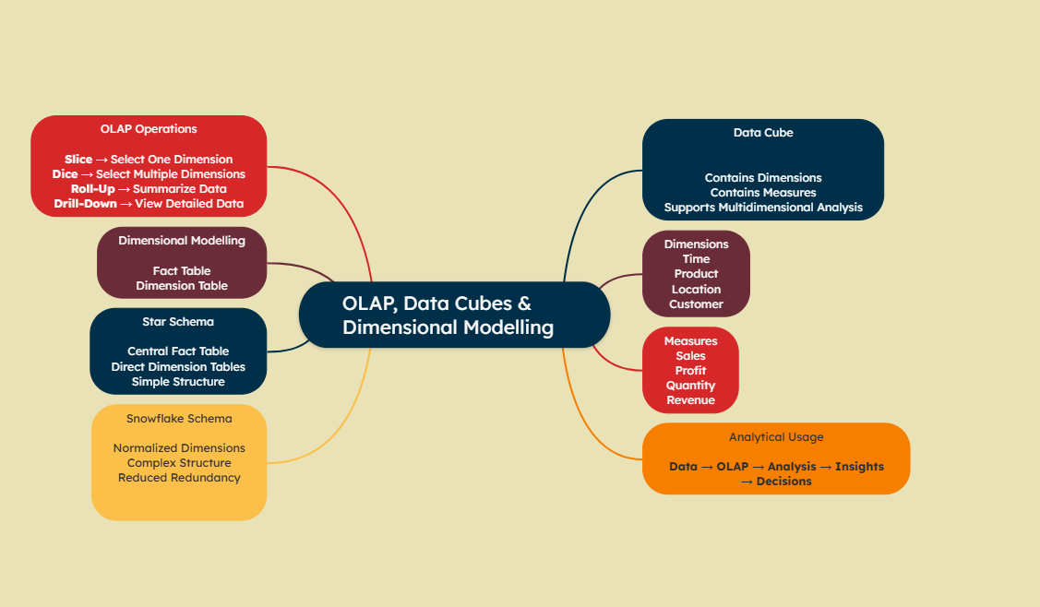

5. Concept Map 5: Query Processing &amp; BI Tools (KNIME)
Task Description:
Construct a concept map explaining how query processing integrates with BI tools, focusing on KNIME for
reporting and OLAP applications.
1. Query processing stages (Parsing, Optimization, Execution)
2. Role of BI tools
3. KNIME workflow structure
4. Data → Query → Visualization pipeline
5. OLAP application integration

